UNIT/06: FAME AND THE MEDIA

READINGREADING
IN THIS unIT YOU WILL
LEARN HOW TO
- scan a text to find information quickly
- answer True/False/Not Given questions
- complete a summary of a text.

Lead-in

 | Can you name these sports?
  01
  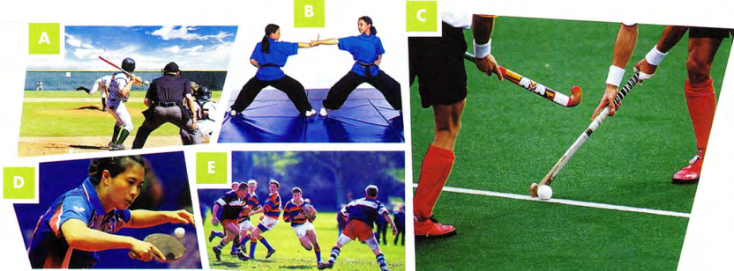
 | Match the sports 1-9 with the descriptions a-l in the box. Each sport matches several descriptions.
  02
  - Hockey  - tennis  - volleyball | - football  - rugby  - baseball | - table tennis  - martial arts  - basketball
  - It's a team sport. | - You hit the ball over a net. | - It's played with a ball.
  - You score goals. | - You hit the ball with a bat. | - You tackle other players.
  - There's a goalkeeper. | - You can play singles or doubles. | - You use a racket.
  - You earn coloured belts. | - You mustn't run with the ball. | - You play on grass.
 | Which of these sports have you played or watched? Which would you like to try?
  03

[[[[[[[[[[TRUE / FALSE / NOT GIVEN]
◉ In this type of task you have to say if a statement is True (it agrees with the information in the passage), False (it does not agree with the information in the passage - it says the opposite, or something different) or whether the information in the statement is Not Given in the passage (there is nothing in the passage to indicate if it is true or false). You must give your answer only according to what is in the passage - you must not use your own knowledge about the topic.
The questions are in the same order as the information in the text.

 | Read the text in ONE MINUTE.  Tell your partner anything you can remember. Don't worry about giving exact information. You could use these expressions.  There was something about...  I don't remember the details, but it involved...  There's a game which is a bit like...
  04

UNUSUAL SPORTS
A  Do you ever get bored with the same old sports? If you're tired of tennis, fed up with football or bored of basketball, don't worry. There are plenty of new and unusual sports out there for you to try. Many of these are a mix of existing sports, sometimes with a local element added. Bossaball, for example, is a mix of football and volleyball, played on an inflatable pitch with a trampoline in the middle. To make it more exciting, it also has elements of Brazilian martial arts!  B  If you are very good at horse riding, you could try the national sport of Afghanistan, buzkashi. Many versions have been played in the Central Asian region for hundreds of years. The game involves players on horseback trying to get hold of a dead goat. The Afghan Buzkashi Federation wants the game to spread throughout the world and has finally written down the rules because they hope to get Olympic status for the sport. | C  A sport that is more likely to become famous is kabaddi. It is popular in India and other parts of South Asia. It is similar in some ways to the game called 'tag' or 'it' which schoolchildren play. One person is 'it' and has to catch the others. In kabaddi, a 'raider' from one team tries to tag a player from the other team and then return to their own half of the field without getting caught. In some versions of the game, the raider must chant the word 'kabaddi' as he returns to his place. Kabaddi is good fun, good exercise and doesn't need any equipment. It is played at the Asian Games.  D  There is an unusual sport which describes itself as a 'classic mix of brains and brawn'. The game, called 'chess boxing', involves a round of chess and then a round of boxing, then another of chess, and so on. There is one minute between rounds. The first chess boxing world championship took place in 2003 in Amsterdam and was won by a Dutchman, lepe Rubingh. Since then, it has become more popular, particularly in Germany, the UK, India and Russia. It is a difficult sport, as players need to be very good at two very different activities and be able to switch quickly between the two.  E  Finally, an unusual sport that will be familiar to most of us is roshambo, which began in China about 2000 years ago and spread gradually to the rest of the world. Played by young and old, in the UK it is known as 'rock-paper-scissors'. It is surprising that it is called a sport and taken so seriously: there's a World Rock Paper Scissors Society and a league which holds championships every year. So, whatever kinds of sport you like, there is something new and interesting for you to try.

 | Quickly scan the text to find the paragraph which contains information about these sports as quickly as you can.  - a sport which is trying to get into the Olympic games  - a sport which has been played for more than a thousand years and  - is based on an activity most of us know  - a sport influenced by two very popular sports  - a sport which may involve repeating a word  - a sport which involves two activities which are very unlike each other |  | TIP 05
  05
  When answering True/False/
  Not Given questions you must scan the text to find the information as quickly as possible, as you also need time to read a few sentences in detail.
 | The following questions relate to the sections you just found. Decide if they are True or False.  - Players of chess boxing only need to reach a high level in one of the activities.  - Buzkashi got written rules long after the game first started.  - Roshambo can be played by anyone, even children and the elderly.  - Bossaball is played on grass.  - It could be quite expensive to play kabaddi.
  06
 | Does this statement agree with the information in the passage?  Write True, False or Not Given.  - 1 Kabaddi is only played by men.  Hint: You ONLY need to read the paragraph about kabaddi, which is paragraph C. You will already know from your initial skim reading that information about kabaddi is not found anywhere else in the text. | TIP 07
  07
  Don't waste time going through the whole passage to find the information. Not Given answers will relate to one part of the text. Once you have read the relevant part in detail, if you can't find the information, choose Not Given.
 | Read only the relevant paragraphs. Is this information True (write T) or Not Given (write NG)?  - Bossaball is only played in Brazil.  - Buzkashi is sometimes played with a sheep instead of a goat.  - There are different versions of the game kabaddi.  - Chess boxing is played in several different countries.  - The roshambo world champion is from China.
  08
 | Answer True, False or Not Given to these questions about the text.  - People play bossaball on a soft surface.  - Buzkashi is an Olympic sport.  - Kabaddi is often played in schools.  - lepe Rubingh invented chess boxing.  - lepe Rubingh is from Germany.  - People consider roshambo a serious sport.
  09

[[[[[[[[[[SUMMARY COMPLETION]
◉ In this type of task you have to choose words to complete a summary of the text, or part of the text.
Sometimes the instructions tell you to choose words from the passage to fill the gaps.
Sometimes you are given words in a box and you have to choose the correct ones. Not all the words in the box will be needed.

 | In the task below you have to fill the gaps by choosing words from the box. Look at gap 1 and follow the steps in the example. Then complete gaps 2-6.  Complete the summary using the list of words A-L below.  If you have had enough of the ordinary sports people play, you can try a number of 1 K new sports. Some of these were created when people 2 ___ two well-known sports. Sometimes they added a 3 ___ from the part of the world where they live. Bossaball is an example of this. It takes volleyball and football, adds a trampoline and some Brazilian martial arts. Buzkashi, a sport from Afghanistan, is played on 4 ___ and uses a dead goat instead of a ball! People in Afghanistan would like this sport to become international. Chess boxing is a sport where you need to 5 ___ rapidly from one type of activity to another. You need to be 6 ___ and also fit. It is becoming more and more popular and now holds world championships.
  10
  ◉ Example
  Notice that gap 1 is followed by an adjective (new) and a noun (sports).
  This tells you that the word you need could be an adverb or an adjective.
  There are adjectives in the box, but no adverbs.
  The adjectives are boring and strange.
  A writer is unlikely to suggest boring sports.
  The answer is strange. This matches what the text says.
  - boring | - change | - clever | - feature | - horses | - join
  - mixed | - moving | - serious | - sport | - strange | - trampolines

GRAMMAR FOCUS: COMPARATIVES

 | Complete these comparative sentences with your opinions on the sports in the text.  - Kabaddi is faster than roshambo.  - ___ is more dangerous than ___.  - ___ is more exciting than ___.  - ___ is harder than ___.  - ___ is not as unusual as ___.
  11
  ◉ Kabaddi is a sport that is more likely to become famous.
  Since then it has become more popular...

[[[[[[[[[[EXAM SKILLS]
 | Skim read the text for one minute before moving on to answer the questions on the next page.  PARKOUR
  12
  A  Parkour was developed in France in the 1980s by  Raymond Belle and later by his son David Belle and his friends. It is based on military obstacle course training. The aim is to get from one point to another in any way you can, and express yourself while doing so. There are no limits on how you move in parkour: running, climbing, swinging, jumping, rolling and any other types of movement are possible. Parkour is more of a philosophy or set of ideas than a sport. It is a new way of seeing the environment and finding ways to go over, under, around, across or through obstacles.  B  Parkour can be done alone or in groups. The most  famous group of traceurs (people who do parkour) were the Yamakasi, a group made up of David Belle and his friends and cousins. They formed in the late 1980s and became popular during the 1990s and 2000s after appearing in several films, documentaries and advertisements. In the Yamakasi, there were strict rules. Members had to arrive on time and they were not allowed to complain or make excuses. They valued humility, so they were not allowed to show off or compete with other members.  C  Parkour is a 'state of mind'. It is about getting over  mental as well as physical barriers. It teaches people to touch the world and interact with it. It is about understanding what it means to be human. The organisation Parkour.net believes that parkour can never be a competitive sport. It is an art and is concerned with self-development. They say you can't ask, 'Who is the best at parkour?' Raymond Belle's advice is: 'If two roads open up before you, always take the more difficult one. Because you know you can travel the easy one. | D  There are some gyms and camps where you can practise and learn parkour. However, many traceurs do not like the idea of special places for their activity. The idea behind parkour is to adapt to any environment and be creative about how you get through it. It is about freedom and self-expression. The founder of parkour refused to teach people how to do moves or get over obstacles. The whole point is to learn your own technique and way of moving. So the idea of having classes or a limited space to practise in conflicts with the values of parkour.  E  Parkour is also known as freerunning. Sometimes freerunning refers to another form of parkour developed by Sebastien Foucan, which has more focus on the individual. The term freerunning came out of the film Jump London (2003). It told the story of three French traceurs practising parkour around the famous monuments of London. Freerunning was the English translation of parkour. There are more similarities than differences between the two activities, and the Parkour UK website uses the two terms to refer to the same activity.

 | Questions 1-8  Do the following statements agree with the information in the text?  Write  - You have to use a limited number of moves in parkour.  - Parkour is mainly done in the countryside.  - Parkour began in the twentieth century.  - The Yamakasi did not allow latecomers.  - When doing parkour, Raymond Belle recommends that you always choose the easy route.  - There are many gyms in France where you can do parkour.  - The founder of parkour was a very good teacher of parkour.  - Freerunning and parkour are similar.  Questions 9-15  Complete the summary of the text using the list of words A-M below.  Parkour is an activity that involves 9 ___ in many different ways through different environments. People who practise parkour are called 10 ___. They believe that parkour is not a sport and can never be part of a 11 ___. The values of parkour are adaptability, 12 ___and freedom. Parkour should not be taught because it is about discovering your own way of moving and overcoming 13 ___. Although there are gyms and other places where you can learn and practise parkour, many feel that this 14 ___ with the values of the discipline. Freerunning is a type of parkour. However, it is more about 15 ___ development than parkour, which is often, but not always, done as part of a group.  Use the strategies you have learnt:  - Read the whole summary first.  - Decide what type of word is needed for each gap.  - Make a prediction before looking at the words given.  - Remember that there are more words than gaps.  - Read the sentence, checking for grammar and meaning. | TIP 12
  12
  TRUE | if the statement agrees with the information
  FALSE | if the statement contradicts the information
  NOT GIVEN | if there is no information on this
  - agrees | - barriers | - competition | - conflicts | - creativity
  - latecomers | - move | - moving | - personal | - respect
  - team | - tournaments | - traceurs
  Be careful of words like some, often, occasionally that change the meaning of a sentence. For example, some sports does not mean the same as many sports.

UNIT/06: FAME AND THE MEDIA

WRITING
IN THIS unIT YOU WILL
LEARN HOW TO
- organise and write a Part 2 essay
- compare two different time periods
- link and signpost your ideas.

Lead-in

 | Choose the correct option(s). In each case, either one or two are correct.  - go running/go for a run / go for running  - go to the cinema / go to cinema / go for the cinema  - see a film / look at a film/ watch a film  - visit to friends / visit friends / visit some friends  - play the sports / play sport/ play sports  - join to a club / join a club / join for a club  - go walking/ go to a walk / go for a walk  - go gym / go to the gym / go for the gym  Which of the activities do you enjoy doing?
  01

[[[[[[[[[[EVALUATING A PART 2 ESSAY]
 |  | Read a student's essay on the following topic. (Ignore the highlighting for now.) What are the good things about it?  MODEL ANSWER
  02
  People nowadays spend their free time less actively than in the past. Do you agree or disagree?
  Some people are saying that people are less active than they were in the past. There are points for and against this idea, but overall I agree with the statement. In this essay I explained why.
  In my opinion, the main reason why people less active is computers. Several years ago we go to speak to our colleagues. We walked to their desk or office. Now we send an email without getting up from our seat. Even our free time is less active because we playing computer games and go on social media. Before, people were walking to a café to meet their friends or they went to their house. Nowadays, though, we chat online at home. In the twentieth century, children do many activities. In today's world, parents are scared for their children's safety, so they prefer to keep them at home. For many, it is easier to stay at home than to go out.
  On the other hand, some physical activities are become more popular. There are more gyms than there used to be and it is fashionable to go running or to the gym. In my view, though, only some people do these things. Most people join a gym but they are not going regularly. However, they never stop playing computer games and watching TV! Also, these days everyone took their driving test as soon as possible and starts driving. In the past, young people walked and went by bus.
  To sum up, I am agree that people are less active in their free time compared with the past. Now people are lazier and less fit than they were before. (273 words)
 | Answer these questions about the essay.  - Does it have the right number of paragraphs?  - Is every paragraph clear?  - Are linking expressions used?  - Is the writer's opinion given clearly?  - Has the writer looked at both sides (for and against)?  - Are tenses used correctly?  - Are there any grammatical mistakes?
  03
 | - The teacher has highlighted the student's errors. Can you correct them?
  04

GRAMMAR FOCUS: COMPARING PAST AND PRESENT

 | In the essay, the student is comparing the situation now with the situation in the past. Complete the expressions she uses to refer to the present or the past. | TIP 05
  05
  Present | Past
  n __ w  n __ d __ s  i __ t __ ‘s w __ d  th __ days | b __ o __ e  __ the p __  s __ ral years ___  t __ r __ u __ d to b __
  Try to use different phrases to compare past and present or present and future. Make a list of them, as this kind of question is quite frequent.

 | Look at the following sentences from the essay:  People are less active.  Some physical activities are becoming more popular.  People are lazier and less fit.  It is easier to stay at home.  Choose the correct form to make some more comparisons between the past and present.  - Joining a gym is expensiver / more expensive than it used to be.  - It is more hard / harder to find the time to do exercise.  - Most people eat healthier / more healthy food than they did before.  - It is dangerous / more dangerous for children to play outside.  - The pace of life is faster / more faster than it used to be.
  06

LINKING IDEAS

 | Find the following expressions in the essay.  - two expressions used to give an opinion  - two expressions used to introduce the opposite view  - an expression to show there are two sides to the argument  - an expression to introduce the conclusion  - an expression to show that a point is the most important
  07
 | Read this Writing Part 2 question and then, before you read the essay in exercise 9, think of some advantages and disadvantages.
  08
  Some children spend most of their free time taking part in clubs and other planned activities. Do the advantages of this outweigh the disadvantages?

 | Fill in the gaps in the essay with the linking expressions in the box.  Many parents think that their children should have many free-time activities, such as joining sports clubs and having music lessons. Children often have no time which can really be called free time. In this essay I will look at the advantages and disadvantages of this and give 1 ___.  2 ___, if we think of all the great artists, musicians and sportsmen and women in the world, they all started by doing their activity as a hobby. They found they had a talent and developed their skills to become world class. Secondly, children usually enjoy their activities, make friends and become well-developed people.  3 ___, parents think that being busy will stop the children getting into trouble. Their parents know what they are doing at all times.  4 ___ , this is not always a positive trend. 5 ___  children can become stressed when they have to run from activity to activity.  6 ___ , they need time to play freely and use their imaginations. They can get to know themselves and their likes and dislikes during this time. It is important to give them time to relax, watch TV, read and be with 7 ___ their parents, grandparents and siblings.  8 ___ that we need to have a balance. Children should choose one or two activities they really like, and have free time to just be themselves the rest of the time.
  09
  My own view is | Unfortunately | Firstly | also
  my own opinion | One reason is that | Thirdly | In addition

[[[[[[[[[EXAM SKILLS]
 | Read the following essay question and then write Agree (A) or Disagree (D) next to each point 1-6 below.  Children are now less active in their free time than in the past. Therefore, sports lessons must be compulsory in schools. To what extent do you agree or disagree? Give reasons for your answer and include any relevant examples from your own knowledge or experience.  Write at least 250 words.  - If people are unfit, the government will have to spend a lot of money on medical care in the future.  - Physical activity improves children's mental well-being.  - Sports lessons are a waste of valuable study time.  - Schools need to spend a lot of money on sports facilities.  - Sports help children learn discipline and working with others as a team.  - Some young people do not enjoy sports.
  10
 | Write your essay using the following plan:
  11
  Paragraph 1 | Introduction - a general opening sentence (a paraphrase of the question)  I agree or I disagree - in this essay I will give reasons
  Paragraph 2 | Summarise the opposite view: Some people believe...  Say why you disagree with them - give your main point
  Paragraph 3 | Give your view - at least two more points, with supporting evidence
  Paragraph 4 | Conclusion - state your view again and give a brief summary of your main arguments
 | Check your essay using this checklist.  - Are my paragraphs clearly shown? (leave a line or indent)  - Have I used linking words and expressions?  - Have I used phrases to introduce my opinion?  - Are my tenses correct (mostly present and future)?  - Have I checked my spelling, grammar and punctuation? | TIP 12
  12
  In the exam, leave a few minutes at the end to read through your essay with a checklist like this one in your mind.

UNIT/06: FAME AND THE MEDIA

LISTENING
IN THIS unIT YOU WILL
LEARN HOW TO
- understand a description of a place
- follow directions
- label a map
- recognise distractors.

Lead-in
 | Match the places in the box with pictures A-E.  Useful verbs  Useful prepositions of place  Check with a partner. Did you get the same answers?  Can you think of any more useful words for giving directions?
  01
  behind | go past | go straight ahead / straight on
  in front of | next to | opposite | turn left | turn right
  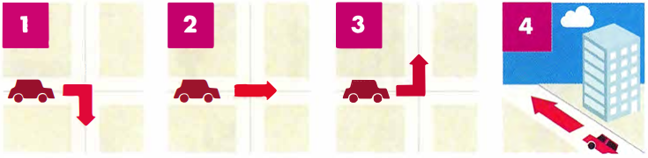
  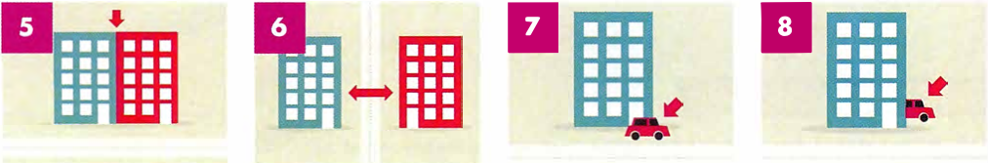
  ◉ A common task in the Listening test is labelling a map. In order to complete this type of question, it is important that you are familiar with words and phrases for giving directions.
 | Describe a route you often take to a partner.  To walk to my local shop, I have to turn left outside my house and then turn right onto a main road. I then walk straight ahead until I get to a mini-roundabout...
  02

[[[[[[[[[[LABELLING A MAP]
◉ There are three types of map labelling task:
- You listen and identify where places are on a map by choosing the correct letter.
- You listen and choose the correct label for places on a map from the list of words provided. There will be more words than you need.
- You listen and label places on a map by writing up to three words.

UNDERSTANDING THE MAP AND THE QUESTION

 | Study the map. What does it show? |  | TIP 03
  03
  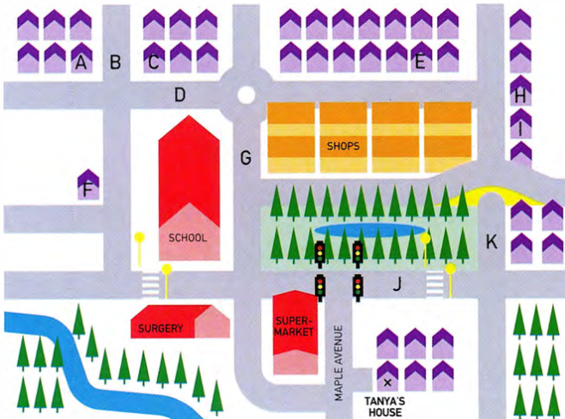
  First read the question and try to understand what the map shows and what you have to do. Then study the map carefully and try to predict the type of language you might hear.
Match the places that appear on the map (the words in the box) with the pictures.
 | 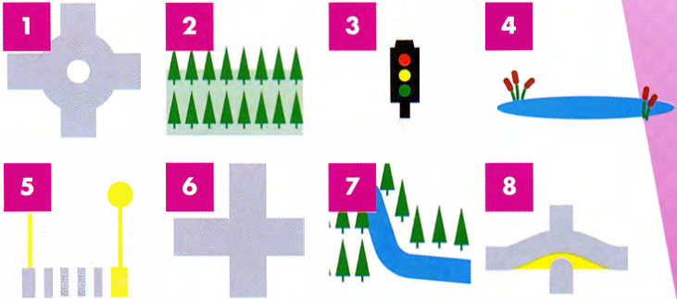
  bridge | crossroads
  park | traffic lights
  river | roundabout
  pond | zebra crossing
Can you think of any other places or features in a town that might be useful when you are giving someone directions?

 | Look at the map and find Tanya's house. Then listen to the phone message. Tanya has offered to give Melissa a lift to a concert. Listen to Melissa giving Tanya directions to her house and label the map. Write the correct letter, A-K, next to questions 1 and 2.  Then listen again and find Melissa's house. Write the correct letter, A-K, next to question 3.  49  - Main Street ___  - Silver Street ___  - Melissa's house ___ | TIP 04
  04
  Once you have understood the map, you are in a much better position to complete the listening task. Note that the questions are in the order in which you will hear the answers on the recording.

 | Now listen to Melissa's second message. She wants Tanya to pick up another friend, Sarah, on the way. Listen and label the map. Write the correct letter, A-K, next to questions 4-6.  50  - New Road ___  - Sarah's house ___  - Oak Avenue ___  Listen again and check your answers.
  05

RECOGNISING DISTRACTORS

 | Read the extracts below from Melissa's messages, and underline any words and phrases which may distract you from choosing the correct answer.
  06
  (Question 1) | Then, you need to turn left at the traffic lights and then take a sharp right onto Main Street. You can also go straight on here, past the surgery, but I usually drive down Main Street.
  (Question 4) | Again, you need to turn right onto Maple Avenue, and up to the lights. Instead of turning left here, turn right, with the park on your left.
  (Question 5) | Drive along New Road until you reach the bridge. Sarah's house is the second house after the bridge. That's on the right; there are shops on the left.
  ◉ The words the speakers use on the recording are often different to the words in the questions. Often, you will hear a synonym (a word with the same meaning or a similar meaning) or a paraphrase (a group of words with a similar meaning, or the same thing expressed in a different way).

MAP OF A BUILDING

 | Listen to Tanya's message to another friend, arranging to meet before the concert.  Listen to Tanya's description and label the map. Choose the correct letter A-H and write the answers next to questions 1-4.  51
  07
  art gallery | restaurants
  cinema | exhibition centre
  live music | Arena
  car park | shopping centre
  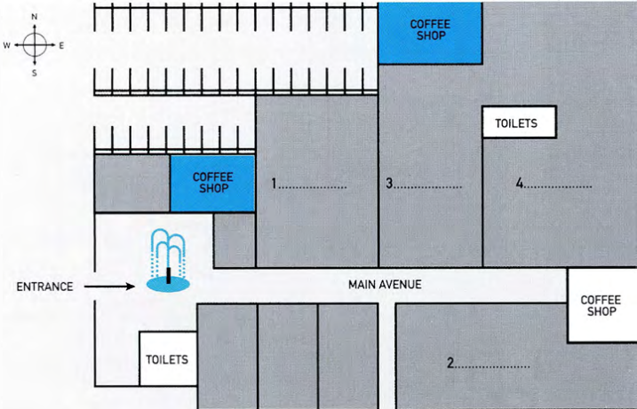
  ◉ In this type of task, you could also be given a map of a building.

MAP OF A PARK

 | at the map with a partner and discuss the different things you can see Look on the map.
  08
  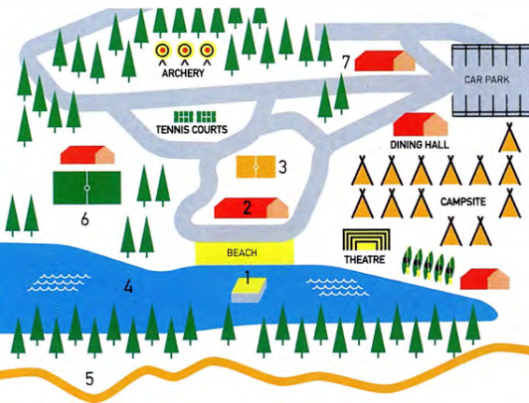
  ◉ Another type of map you might find in a map-labelling task is a map of a park. The illustration below is a map of an activity camp.
 | Listen to the manager giving a tour of the activity camp to a group of teenagers. Label the map with which activity they can do in each place. Use no more than TWO WORDS for each activity.  52
  09

[[[[[[[[[[EXAM SKILLS]
 | You will hear someone giving a talk about plans for a new forest centre.  Label the map. Choose the correct letter A-M and write the answers next to questions 1-8.  53  Pine Woods Centre
  10
  - tickets on sale here  - picnic field  - barbecue area  - Tree Tops Challenge  - playground for young children  - indoor play area  - sheep  - goats | 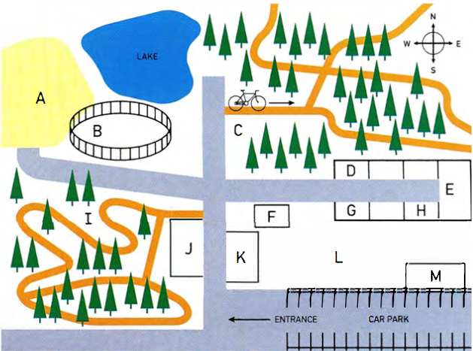

UNIT/06: FAME AND THE MEDIA

SPEAKING
IN THIS unIT YOU WILL
LEARN HOW TO
- use positive and negative adjectives to talk about free-time activities
- recognise and use linking words in your talk (Speaking Part 2)
- pronounce weak forms of words
- give a complete talk and assess your own performance (Speaking Part 2).

Lead-in

 | Ask and answer these questions with a partner.  - Do you do any of the activities in the pictures?  - Which of these activities do you like or dislike?  - Are there any other things you do in your free time? | TIP 01
  01
  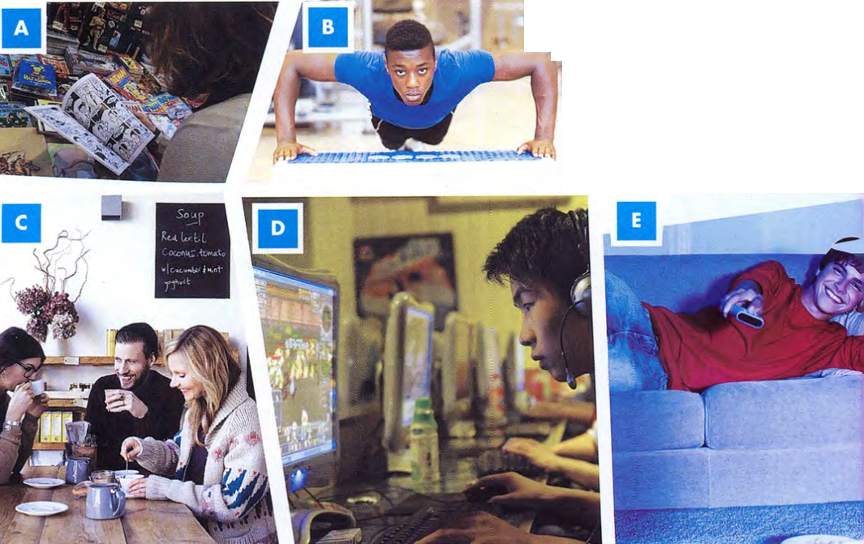
  ◉ In the first part of the Speaking test you may have to answer simple questions about how you spend your free time.
  It is useful to know which verbs go with different sports and activities. Common verbs used with leisure and sports activities include play, do and go.
  play soccer ✔
  do soccer ✗

 | With a partner, use the positive adjectives in the box to say how you feel about various free-time activities.
  02
  amusing | great | enjoyable | excellent | exciting
  brilliant | healthy | peaceful | relaxing
  Examples | Yoga is a very peaceful and relaxing activity.  I am excellent at taekwondo.
 | With a different partner, use the negative adjectives in the box to talk about free-time activities.
  03
  Examples | I feel miserable when I play football in the rain.  Boxing can be an exhausting sport - you need to be fit and strong.
  dangerous | exhausting | useless | harmful | hopeless
  miserable | frightening | tiring | stressful

[[[[[[[[[[EXTENDING YOUR TALK]
◉ It is important to use a variety of language in your talk. It is useful to use linking words such as and, or, but, also, so, in fact, for example, and because. These will make your talk flow better and will help you to give extra information.

 | Listen to a candidate called Serena giving her talk.  54  I'm going to talk about a hobby I'd like to take up in the future. I really want to learn ballroom dancing. This is because I love Latin music and I love the way the dancers move and shake. I also want to give myself a challenge and learn something new. Watching ballroom dancing always makes me feel excited. I don't think it'll be too difficult for me, because I already do ballet and tap dancing. I like learning new steps. For example, I really want to learn the tango or the samba because these are exciting and look good to people watching. I've tried Flamenco dancing but I'm not very good. I'm also worried about finding the right dance partner, because I'll be a little slow to learn in the beginning. So I might fall over sometimes. In fact I'll probably fall over quite a lot!
  04
 | The words Serena uses to connect her ideas are in bold. Match phrases 1-7 with the connecting words and phrases A-G.  Listen again and check your answers.  54
  05
  - This is because I love Latin music  - I love the way the dancers move and shake.  - I like learning new steps  - I really want to learn the tango  - I've tried Flamenco dancing  - I'm also worried about finding the right dance partner  - I might fall over sometimes. | - In fact, I'll probably fall over quite a lot!  - For example, I really want to learn the tango  - or the samba  - I also want to give myself a challenge  - but I'm not very good.  - and I love the way the dancers move and shake.  - because I'll be a little slow to learn in the beginning.
 | With a partner, use the positive adjectives in the box to say how you feel about various free-time activities.  - I like [activity] and ...  I like table tennis and I'm a member of my college team.  - I like [activity] because...  - I love [activity], but...  - I'm not keen on [activity] - in fact ...  - I love all kinds of [activity]. For example, ...  - A lot of people in my country [activity]. They also ...  - At weekends I enjoy [activity] or [activity] with my friends.
  06
  baseball | going on social media | dancing | watching TV
  hiking | playing computer games | travelling | sewing
  sport | making jewellery

 | Now, read the script of Marco giving a talk about a leisure activity he would like to do in the future. Choose the correct linking words.  I'm going to tell you about a leisure activity I'd like to do in the future. I'd really like to learn how to play the acoustic guitar. This is (1) because / so I love music (2) and / but I love the beautiful sound this kind of guitar makes. I (3) and / also want to give myself a challenge (4) so / and learn something new. I don't think it'll be too difficult for me (5) but / because I already know how to read music. I play the piano (6) but/ so I'm not very good. I think playing the guitar will be easier. I (7) for example / also like the fact that you can carry a guitar round easily and play it anywhere. (8) For example/Because I can play it in the park (9) but / or on the beach.  I can't think about learning it at the moment (10) and / because I'm too busy. I need to focus on my studies (11) and/or prepare for my exams. I think that I'd like to take up the guitar next year. All my exams will be over by then, (12) so / but I'll have more time, and more money too. (13) In fact, / Because I'll need money to pay for lessons! I think that learning the guitar would change my life in a positive way. If I learn to play it really well, I'll start my own band. I'd love to perform live on stage at a concert. I think that would be fantastic!  Listen and check your answers.  55
  07
[[[[[[[[[[FOLLOW-UP QUESTIONS]
◉ After you have given your Part 2 talk, the examiner may ask you one or two questions related to the topic you talked about.

 | Listen to students answering the following questions.  After listening, practise asking and answering the questions with a partner.  - Do you generally enjoy trying new things?  - Is there any other activity you would like to try one day?  Share your ideas with a partner. | TIP 08
  08
  If the examiner asks you a question at the end of Part 2 you should answer with two or three sentences.

PRONUNCIATION - STRONG AND WEAK FORMS

 | Listen to the following words pronounced (a) when they are stressed and (b) how they might sound in a sentence.  57
  09
   | stressed | weak form
  to  and  a  of  some  for  from | /tuː/  /ænd/  /æ/  /ɒV/  /SʌM/  /fɔːr/  /frɒm/ | /tə/  /ənd/ or /ən/  /ə/  /əv/  /səm/  /fə^{r}/  /frəm/
  ◉ When we speak English, we pronounce the key words in a sentence more clearly than the other words. These are usually nouns, verbs, adjectives. We say the little 'grammar' words (and, some, to, for, of, etc.) quickly and don't give them their full pronunciation. We call these 'weak forms'.

 | Look at the sentences. Underline the words that you think will NOT be stressed.  - I want to learn to play the guitar.  - I enjoy playing football and baseball.  - I bought a new golf club.  - I would like to learn to play chess.  - I need some driving lessons.  - I played drums in a band for a long time.  - I plan to cycle from the north of Africa to the south.  Listen and check your answers.  Practise saying the sentences with a partner.  58
  10
[[[[[[[[[[EXAM SKILLS]
 | Make your own notes for this task card. Use the key words to help you.
  11
  Talk about a new sport or hobby you would like to take up.
  You should say:
  - what it is
  - how you would start it
  - why you have not started it yet
  and explain what help you would need.
 | Use your notes to complete the task with a partner. You should try to talk for two minutes.  Listen to your partner talk on the same topic. Make notes of any interesting vocabulary or phrases they use. Complete the checklist.  Finally, both complete the task again.
  12
  Did your partner talk for two minutes? | YES | NO
  Did your partner cover all four points on the task card?
  Did your partner link their ideas together well?

[[[[[[[[[[MATCHING HEADINGS]  TIP 03 | MODEL ANSWER  [[[[[[[[[[PART 2 QUESTION TYPES]  TIP 03  [[[[[[[[[EXAM SKILLS]
  buy clothes | buy
  go climbing | go
  01
  SKIM READING
  GRAMMAR FOCUS: FUTURE FORMS
  The topic sentence is often, but not always, the first sentence in a paragraph, so that is the first place to look.
  ◉ Matching headings tests your ability to
  ◉ Matching headings tests your ability to
  The pie chart shows which type of takeaway food is the most popular in the UK, while the bar chart shows how many Indian restaurants existed in
  fff
  hh
  fff aspects | dddd
  fff
  hh
  Good | Bad | bbb
  Read newspapers and websites to find out about current issues.
  ◉ In Part 2 you have to write an essay of about 250 words. There are different types of question in Part 2, and .
  The topics in Part 2 are all general and do not need special knowledge.
  WRITING AN INTRODUCTION
[[[[[[[[[[SENTENCE COMPLETION]  TIP 04 | [[[[[[[[[[ORGANISING A PART 2 TALK]  TIP 03
  coffee shop | department store
  aaa | bbb | ccc
  It is important to listen carefully to the ending of words.
  ◉ In this type of task you complete
  ◉ In this type of task you
  FOLLOWING A CONVERSATION
  afford | all sorts of
  place | original
  Lead-in
  ◉ When you are asked to speak on a
  ◉ When you are asked to speak
  Read newspapers and websites to find out about current issues.
  Describe a place where you like going shopping.
  You should say:
  - what kind of place it is
  - where it is
  - what you like to do there
  and explain why you like shopping there so much.
26 K
- a good selection  - at the weekend  - shoes  - under one roof  - walk  - picture | - in one building  - photograph  - on Saturday and Sunday  - footwear  - a wide choice  - go on foot

